**Pizza Sales SQL Queries**

1. **KPI’s**
2. **Total Revenue**

Select sum(total_price) As Total_Revenue from pizza_sales

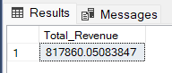

1. **Average Order value**

Select Sum(total_price)/ count(Distinct order_id) As Avg_order_value from pizza_sales

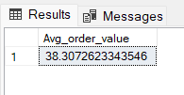

1. **Total Pizza Sold**

Select Sum(quantity) As Total_Pizza_Sold from pizza_sales

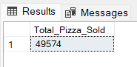

1. **Total orders**

Select Count(Distinct Order_id) as Total_Orders from pizza_sales

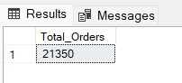

1. **Average Pizza Per order**

Select Cast (Cast (Sum(quantity) as decimal (10,2)) /

Cast(count(Distinct Order_id)as decimal (10,2)) as Decimal (10,2))

as Avg_Pizza_per_order from pizza_sales

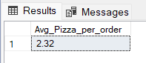

1. **Charts Requirement**
2. **Daily Trend for Total Orders:**

Select DATENAME(DW, Order_date) as Order_day, Count(Distinct Order_id) as Total_orders

from pizza_sales

Group By DATENAME(DW, Order_date)

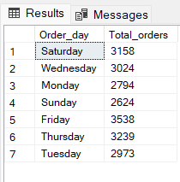

1. **Hourly Trend**

Select Datepart(Hour, Order_time) as Order_hours, Count(Distinct Order_id) as Total_orders from pizza_sales

Group By Datepart(Hour, Order_time)

Order By Datepart(Hour, Order_time)

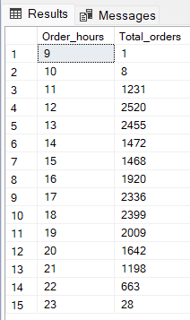

1. **Percentage of Sale by pizza category**

SELECT Pizza_category, SUM(total_price) * 100 /

(SELECT SUM(total_price) FROM pizza_sales) AS Percentage_of_total_sales

FROM pizza_sales

GROUP BY pizza_category;

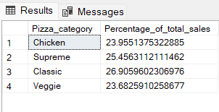

1. **% of Sales by pizza size**

SELECT Pizza_size, CAST (SUM(total_price) * 100 /

(SELECT SUM(total_price) FROM pizza_sales) AS DECIMAL (10,2))AS Percentage_of_total_sales

FROM pizza_sales

GROUP BY Pizza_size

ORDER BY Percentage_of_total_sales DESC;

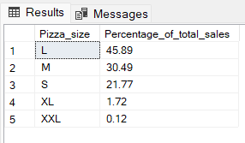

1. **Total Pizza Sold by Pizza Category**

Select Pizza_category, Sum(quantity) as Total_pizza_sold From pizza_sales

Group By Pizza_category

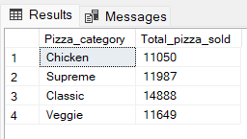

1. **Top 5 Best Sellers by Total Pizza Sold**

Select Top 5 Pizza_name, Sum(quantity) as Total_pizza_sold From pizza_sales

Group By pizza_name

Order By Sum(quantity) desc

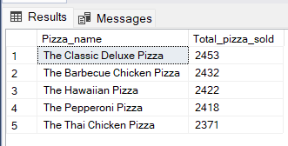

1. **Bottom 5 Worst Sellers by Total Pizza Sold**

Select Top 5 Pizza_name, Sum(quantity) as Total_pizza_sold From pizza_sales

Group By pizza_name

Order By Sum(quantity) asc

